Lab - Mobile Wi-Fi - Android and iOS

1. Objectives

* Familiarize yourself with the Wi-Fi settings on mobile devices.
* Turn the Wi-Fi radio on and off
* Set the device to forget a found Wi-Fi network
* Connect to a new Wi-Fi network.

1. Background / Preparation

In this lab, you will access smartphone operating systems in order to enable Wi-Fi communications and configure connection settings.

1. Required Resources

* Android tablet or smartphone running Android version 4.0 or above
* iOS tablet or smartphone running iOS version 5.0 or above
* Access to a configured wireless network, either within the classroom or a wireless hotspot

1. Configure Wi-Fi settings on an Android device
   * 1. Access the device.

Turn on the device and log in with the password, pin code, or other passcode, if necessary. The main home screen appears.



* + 1. Access Settings.
       1. Touch the notification and system icons.

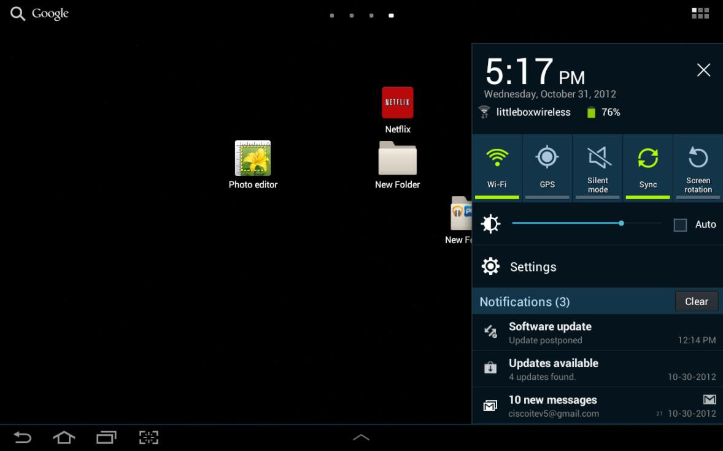

* + - 1. Touch the **Settings** icon.
      2. The “Settings” menu appears.

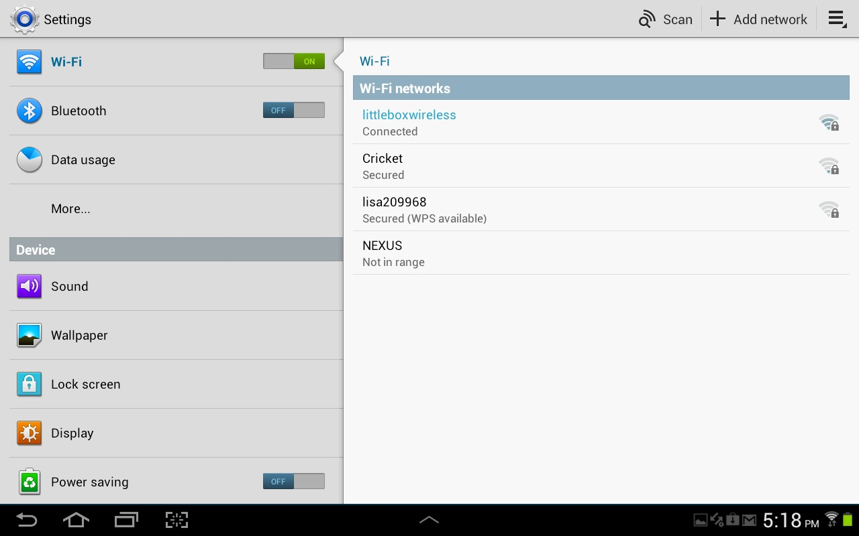

* + 1. Forget a wireless network.
       1. Touch the **Wi-Fi** switch until it is set to **Off**.

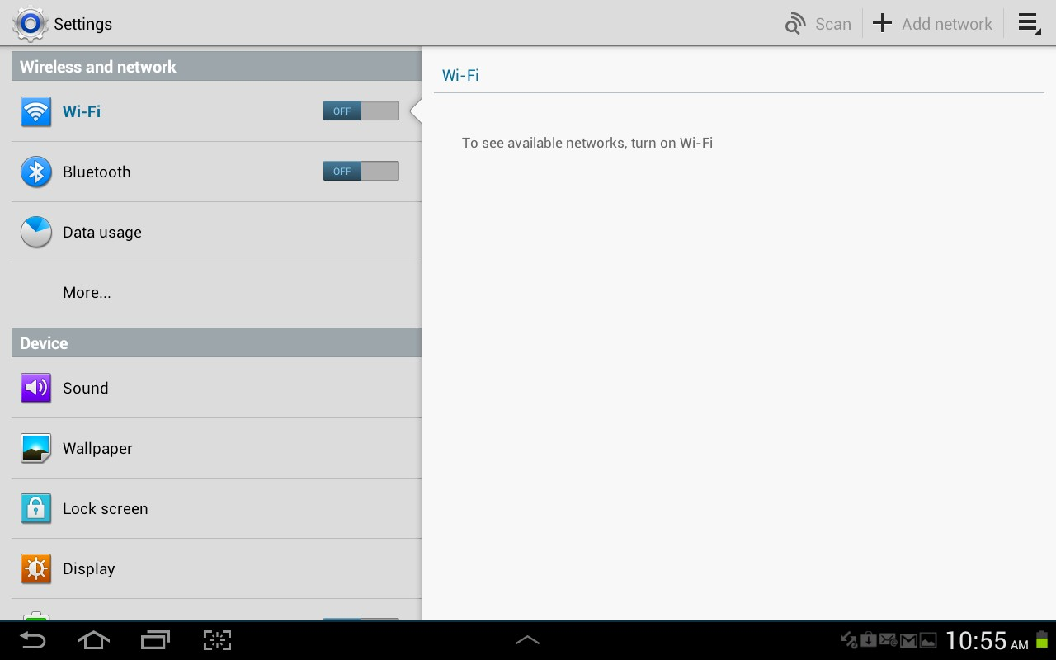

* + - 1. Touch the **Wi-Fi** switch again.
      2. Touch the name of the network to which the device is connected. The “Wi-Fi details” window appears.

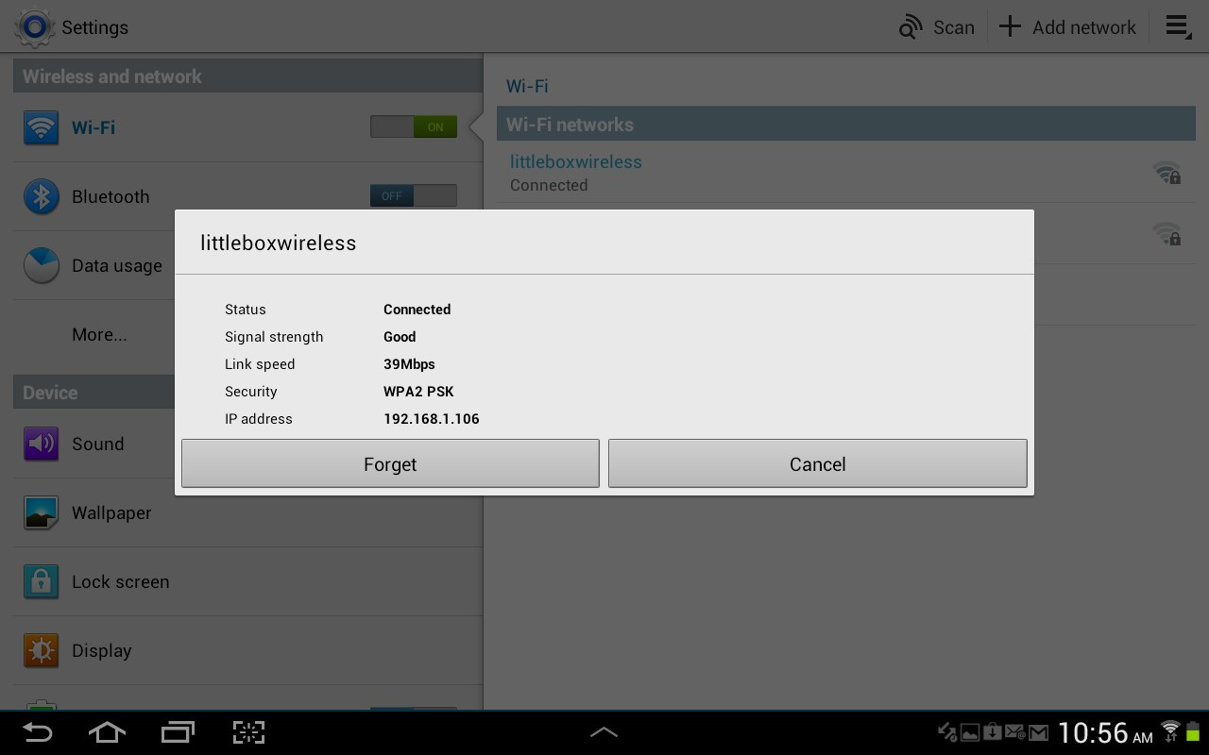

* + - 1. Touch **Forget**. What happens?

____________________________________________________________________________________

____________________________________________________________________________________

* + 1. Connect to a wireless network.
       1. Touch the network to which the device used to be connected.

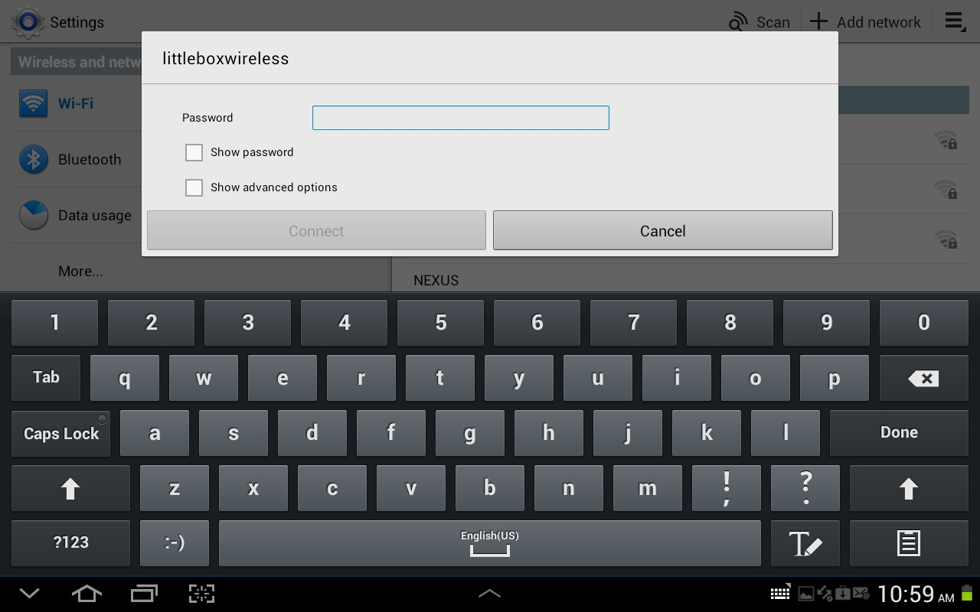

* + - 1. Type the Wi-Fi Password. Touch **Done**.
      2. Touch **Connect**. What happens?

____________________________________________________________________________________

____________________________________________________________________________________

1. Configure Wi-Fi settings on an iOS device
   * 1. Access the device.

Turn on the device and log in with the password, pin code, or other passcode, if necessary. The main home screen appears.

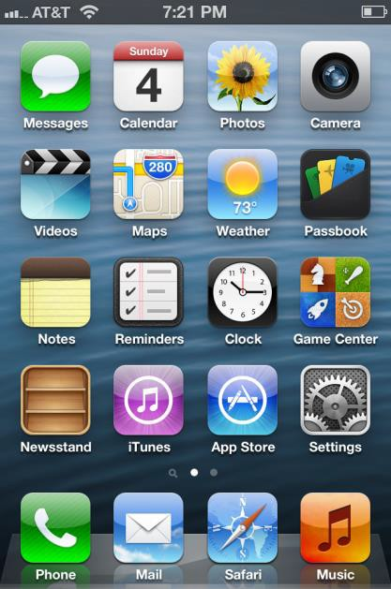

* + 1. Access Settings.

Touch the **Settings** icon. The “Settings” menu appears.

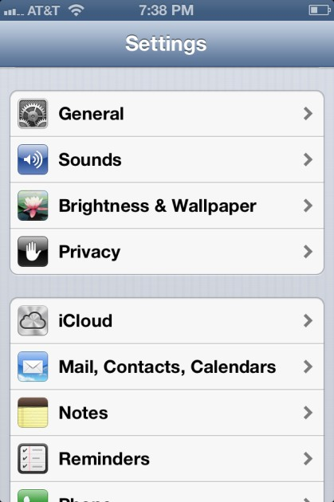

* + 1. Forget a wireless network.
       1. Touch **Wi-Fi**. The “Wi-Fi” menu appears.

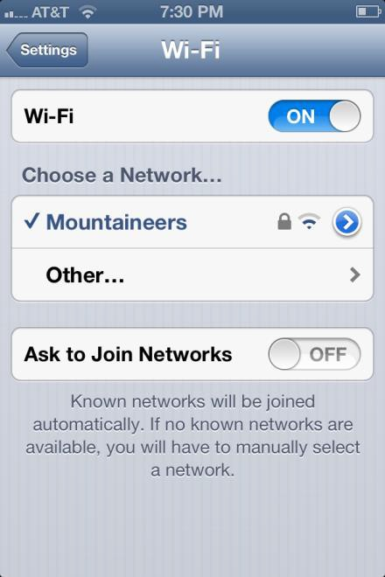

* + - 1. Slide the Wi-Fi switch until it is **OFF**.

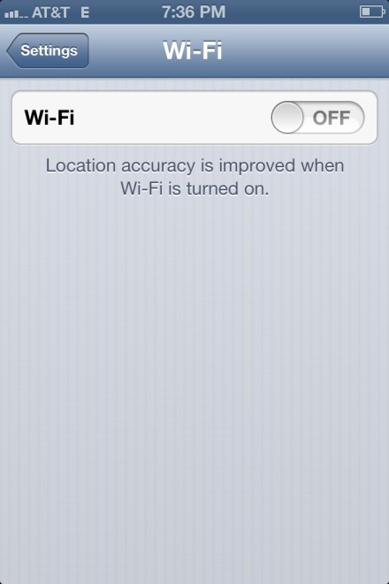

* + - 1. Slide the Wi-Fi switch until it is **On**.
      2. Touch the name of the network to which the device is connected. The “Wi-Fi details” window opens.

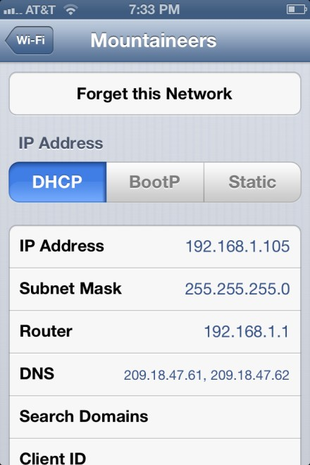

* + - 1. Touch **Forget**. What happens?

____________________________________________________________________________________

____________________________________________________________________________________

* + 1. Connect to a wireless network.
       1. Touch the network to which the device used to be connected.

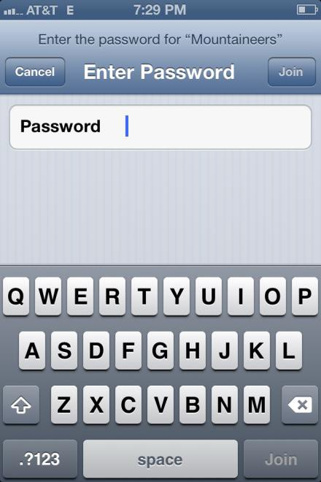

* + - 1. Type the Wi-Fi Password. Touch **Join**. What happens?

____________________________________________________________________________________

____________________________________________________________________________________